Paper Title Format for NRSC on A4 Page Size (12 pt Times New Roman, Bold)
Fname1 I. Lname¹, Fname2 I. Lname2², Fname3 I. Lname3²(10pt Times Italic)
¹Faculty Name, University, City, Country, including e-mail address (10pt Times)
²Faculty Name, University, City, Country, including e-mail address (10pt Times)

Abstract (12 pt Times New Roman Bold)
(Abstract; 10 pt Times New Roman, within 150 words). The Abstract section must not be numbered. This document outlines the necessary details to prepare a paper in a standard style for publishing in the 30th National Radio Science conference. Authors are requested to follow all the formatting instructions encoded into this word file. An easy way to comply with the conference paper formatting requirements is to use this document as a template and simply type your text into it. Papers are submitted in English, 8 pages maximum and one additional extra page for 40 L.E. (Participants from outside Egypt 40 U.S. dollars). Papers should be written in Times New Roman 10 pt format, all margins should be 1.0 inch (2.4 cm) except the top one should be 1.5 inch (3.6 cm).Your paper must use a page size corresponding to A4 which is 210mm (8.27") wide and 297mm (11.69") long.
Keywords: select at least three keywords that best describe your paper (10pt Times Italic)
- Introduction
Title of Section (e.g. Introduction) (12 pt Times New Roman Bold). This document is a template. Paragraphs’ font is 10pt Times New Roman. An electronic copy can be downloaded from the conference website. For questions on paper guidelines, please contact the conference local committee as indicated on the conference website. Information about final paper submission is available from the conference website.
  - Subsection Heading Here
The heading of subsection should be in Time New Roman 12 pt bold. Use the Capitalization Rules of the Main Title. Note that you need to use \ subsections. Subsection text goes here, if applicable. You may or may not have any subsections. That is Ok.
- Sub-subsection Heading: insert sub-subsection text here. the heading of subsection should be in Time New Roman 12 pt italic with initial letters capitalized. Same thing, you may or you may not have sub-subsections. That is fine.
- About this Template: Authors may use the same paper here to produce their own paper.
  - Page Layout
Through the whole paper ( from page layout paragraph settings) use these settings for the headers and sub-section heading select justified for Alignment and select body text for the outline level. As for the indentation, select 0 cm before and after text, As for special select Handing by 0.51 cm. Finally for spacing select 9 pt before text, 3 pt after text and single line spacing. The setting of Sub-subsection is the same as subsection except for the indentation before text is 0,5 cm. For any paragraph set Justified for Alignment and select body text for the outline level. As for the indentation, select 0 cm before text and auto after text, As for special select first line by 0.51 cm. Finally for spacing select 0 pt before text, auto after text and single line spacing.
- System MOdel
Throughout the whole paper the font Time New Romans is used. The header of the paper should be no longer than one line, or at most two. The initial letters of each word should be capitalize, except for: the, a, or, for, in , from, etc.

- Figure Captions
The insertion of figures requires special attention. First, each figure should be inserted where it belongs, as close to the figure reference as possible. Figures should be inserted centered and “in line text” layout format. Figure should be in black and white especially when using different line format. Each figure (group) must include a caption set in 9 pt Times New Roman. The caption is to be centred. Figure numbering and referencing should be done sequentially, e.g. Fig. 1., Fig. 2., etc. for single figures, and Fig. 1(a)., Fig. 1(b)., etc. for figures with multiple parts. Put a blank line before and after the figure, as shown in Fig. 1 and 2.
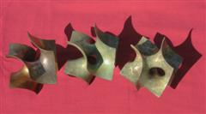
Fig. 1: Short, centered caption, terminated with a full stop.

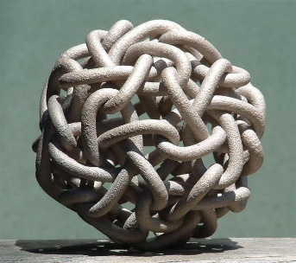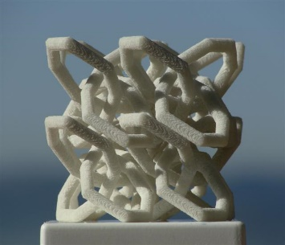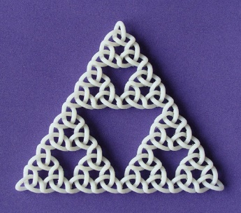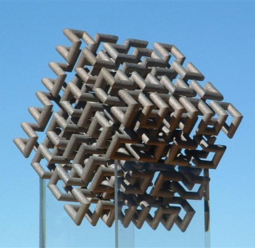
Fig. 2: Here is a longer caption that is left/right justified. It has multiple components that are referred to from left to right. (a) Cube, (b) Dodeca-Pentafoil, (c) Recursive Trefoil Knot, and (d) Lattice of Figure-8 Knots.
- Table Captions
Table should be numbered. Table captions should be centered and in 9 pt Times New Roman. Every word in the table caption must be capitalized except for short minor words as listed in Section III. Captions with table numbers must be placed before their associated tables, as shown in Table 1.

Table 1: Short Captions Should be Centered above each Table
Table Head | Table Column Head
 | Table column subhead | Subhead | Subhead
copy | More table copyª

- Equations
Each equation should occur on a new line with one line spacing adjacent text as indicated below. The equations, where they are referred to in the text, should be numbered sequentially and their identifier enclosed in parenthesis, right justified. The symbols, where referred to in the text, should be italicized.
E = mc² | (1)

- Conclusion
Acknowledgment
Remember, the heading of the Acknowledgment section and the References section must not be numbered
References
The heading of the References and Acknowledgment sections must not be numbered. All reference items must be in 10 pt Times New Roman. Please use Regular and Italic styles to distinguish different fields as shown in the References section. Number the reference items consecutively in square brackets (e.g. [1]).
When referring to a reference item, please simply use the reference number, as in [2]. Do not use “Ref. [3]” or “Reference [3]” except at the beginning of a sentence, e.g. “Reference [3] shows …”. Multiple references are each numbered with separate brackets (e.g. [2], [3], [4]–[6]).
References
- S. M. Metev and V. P. Veiko, Laser Assisted Microtechnology, 2nd ed., R. M. Osgood, Jr., Ed. Berlin, Germany: Springer-Verlag, 1998.
- J. Breckling, Ed., The Analysis of Directional Time Series: Applications to Wind Speed and Direction, ser. Lecture Notes in Statistics. Berlin, Germany: Springer, 1989, vol. 61.
- S. Zhang, C. Zhu, J. K. O. Sin, and P. K. T. Mok, “A novel ultrathin elevated channel low-temperature poly-Si TFT,” IEEE Electron Device Lett., vol. 20, pp. 569–571, Nov. 1999.
- M. Wegmuller, J. P. von der Weid, P. Oberson, and N. Gisin, “High resolution fiber distributed measurements with coherent OFDR,” in Proc. ECOC’00, 2000, paper 11.3.4, p. 109.
- R. E. Sorace, V. S. Reinhardt, and S. A. Vaughn, “High-speed digital-to-RF converter,” U.S. Patent 5 668 842, Sept. 16, 1997.
- (2002) The IEEE website. [Online]. Available: http://www.ieee.org/
- M. Shell. (2002) IEEEtran homepage on CTAN. [Online]. Available: http://www.ctan.org/tex-archive/macros/latex/contrib/supported/IEEEtran/
- FLEXChip Signal Processor (MC68175/D), Motorola, 1996.
- “PDCA12-70 data sheet,” Opto Speed SA, Mezzovico, Switzerland.
- A. Karnik, “Performance of TCP congestion control with rate feedback: TCP/ABR and rate adaptive TCP/IP,” M. Eng. thesis, Indian Institute of Science, Bangalore, India, Jan. 1999.
- J. Padhye, V. Firoiu, and D. Towsley, “A stochastic model of TCP Reno congestion avoidance and control,” Univ. of Massachusetts, Amherst, MA, CMPSCI Tech. Rep. 99-02, 1999.
- Wireless LAN Medium Access Control (MAC) and Physical Layer (PHY) Specification, IEEE Std. 802.11, 1997.

